ST PATRICK’S COLLEGE, BALLYMENA GCE RESULTS, AUGUST 2020
100% Pass Rate across All Courses
Seven subjects with 100% at A*-C

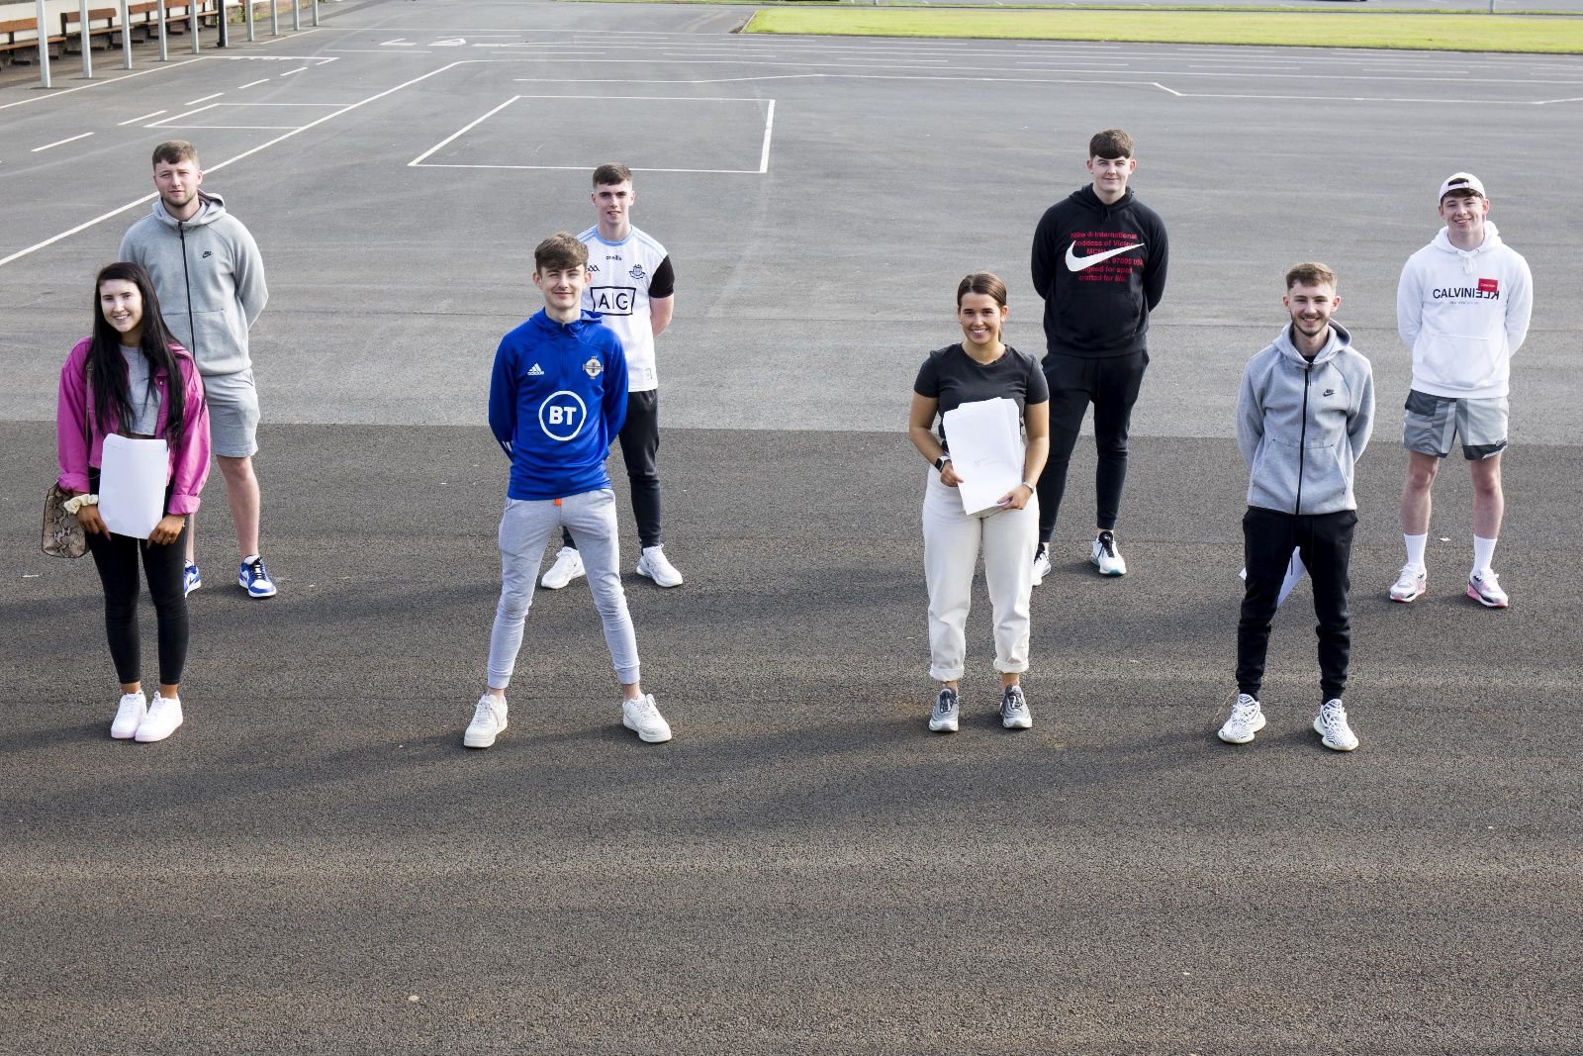
Year 14 BTEC Sport students at St Patrick’s College. 82% of BTEC Sport grades were at Distinction*/Distinction level.

Overall, St Patrick’s College Sixth Form students have seen great success this year. 46% of our Year 14 students achieved at least two A/A* grades. This level of success clearly demonstrates a high level of achievement.

In total, 33 A or A* grades have been achieved by the College’s Year 14 students, accounting for 55% of the total grades obtained by our Sixth Form students.

This year’s results were calculated from Centre Assessed Grades, which were then moderated by the examination boards, taking into account a range of evidence including the previous performance of students in AS exams and the previous performance of the school.

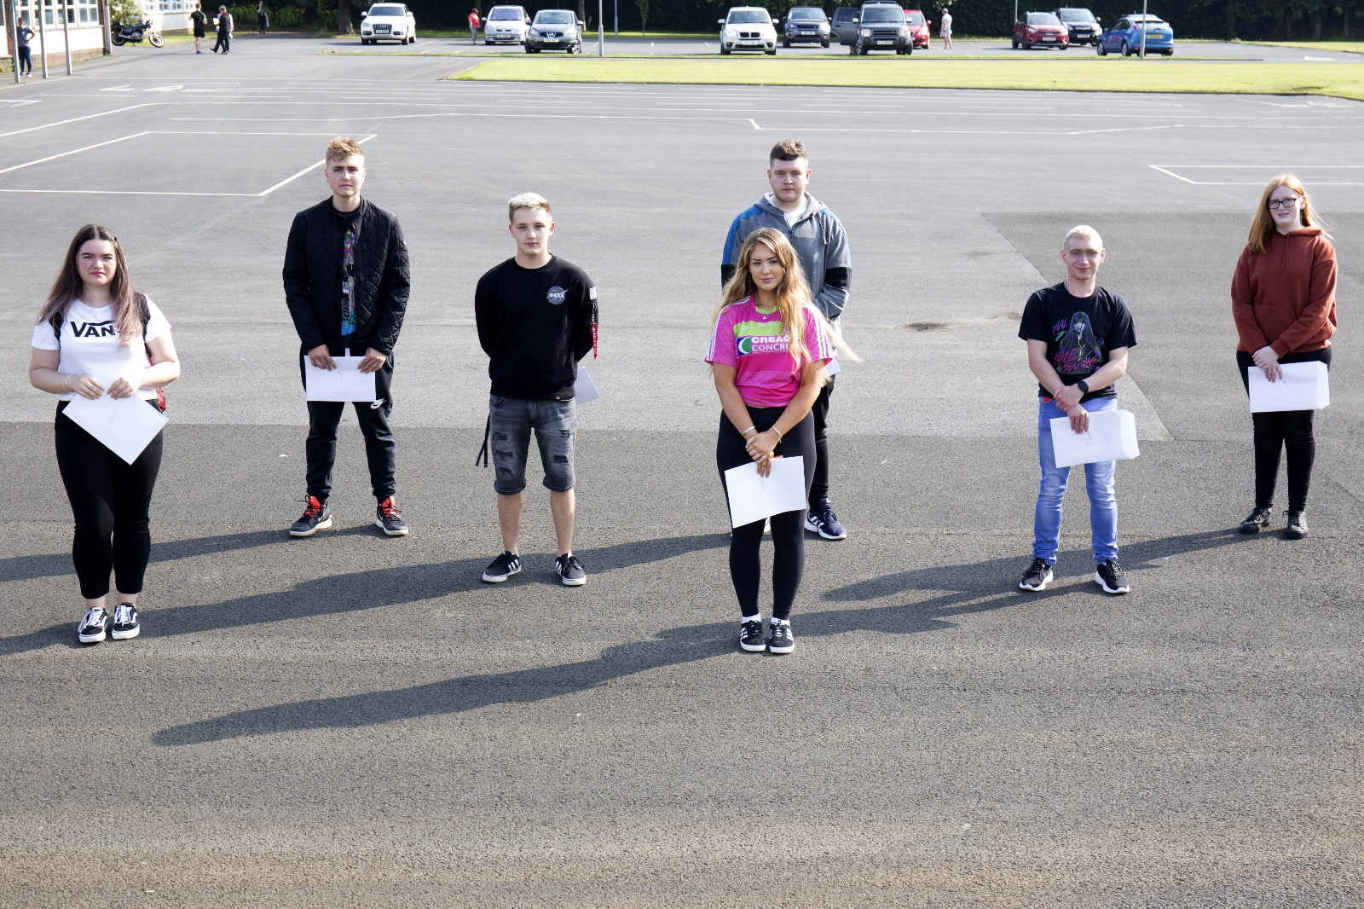
Year 13 and 14 St Patrick’s students celebrating their results.

Three students are celebrating the achievement of three grades at A or A*, while six students have achieved at least two A* grades.

71% of the College’s Year 14 students are celebrating at least one A grade in their ‘A’ Level results this week, with 38% also celebrating at least one A* grade.

Year 13 students have also enjoyed considerable success in their AS Level courses, where an encouraging number of students have achieved A-C grades.

St Patrick’s College Principal, Dr Martin Knox, congratulated all of his ‘A’ Level students on their outstanding level of achievement.

‘I am delighted to see so many of our students achieving at this top level and it is testament to the effort that they and their teachers have put into their ‘A’ Level work over the past two years. This has been an extremely unsettling year for young people, but our A2 students’ excellent results are testament to the strong work they had put into their AS Year and into Year 14 up to the point where schools had to go into lockdown.

‘Eleven of our students have achieved at least two A grades out of their ‘A’ Levels, and I am delighted that we have a 100% pass rate across all of our courses to celebrate, with 100% of students taking three A Levels passing all three. A particular word of congratulation must go to our Art, Construction, ICT, Performing Arts, Polish, Religious Studies and PE Departments, which all saw 100% of their students achieve grades at A*-C. All Year 14 Polish students achieved A* or A grades. Over 90% of our Year 14 Art and ICT students achieved Distinction grades. All of our Construction students achieved a Starred Distinction (A*) grade. I particularly congratulate the three students who achieved three A or A* grades.

‘We are very pleased that such a significant number of our students have achieved three of their ‘A’ Levels at A*-C, and I am delighted to say that our students have achieved excellent results in both their AS and A2 courses. I particularly congratulate Year 14 students Kinga Biernat and Rhiannon McArdle, both of whom took four A Levels and both of whom have achieved outstanding results across their subjects.

‘We have many Sixth Form students who come to us from other schools when they have completed their GCSE courses, and their success at ‘A’ Level shows how well they settle into life here at St Patrick’s. It is notable that four of these students are among our very highest achievers.’

Dr Knox congratulated and thanked his staff for the support, guidance and advice they have given the school’s young people during their ‘A’ Level studies. He further congratulated the students’ parents, who have provided unfailing support to their children during this very busy two year period, as well as during the period of lockdown.

Further success has been achieved at AS Level, where St Patrick’s students have completed a highly successful first year of their ‘A’ Level courses.

Over a quarter of all grades achieved at AS Level were at A*-B grades, an outstanding achievement on the part of both students and teachers. Dr Knox also offered his congratulations to these students:

‘The very high level of success achieved by these young people in the first year of their ‘A’ Level programmes gives them every encouragement to go on and achieve further success next year in their A2 year.’

Dr Knox also congratulated the College’s Year 13 Transition Course students, who have all achieved success in their courses.

‘I congratulate our Transition Course students on the outstanding success they have achieved. This course has equipped the students with a number of valuable qualifications, which they will use to progress to the next stage of their education, either here at St Patrick’s or in Further Education.’

Dr Knox concluded by wishing the Sixth Form students who will be leaving the College this year every success in the future as they move on to Further and Higher Education and into the world of work. He thanked them for the outstanding contribution they have made to the school, and also for the example they have given younger pupils at St Patrick’s, through their excellent academic performance, their work as Pupil Mentors to the younger pupils and the many other ways in which they have taken part in the life of the school. Undoubtedly they have followed the school’s Mission Statement of living and practising their faith and their commitment to one another. He said, ‘They have been outstanding role models to the other pupils and exemplary young people, and we at St Patrick’s College wish all of them every success in the future.’

