St Patrick’s College, Ballymena
Best GCSE Exam Results EVER!

Students in St Patrick’s College, Ballymena are celebrating their best ever GCSE results this year.
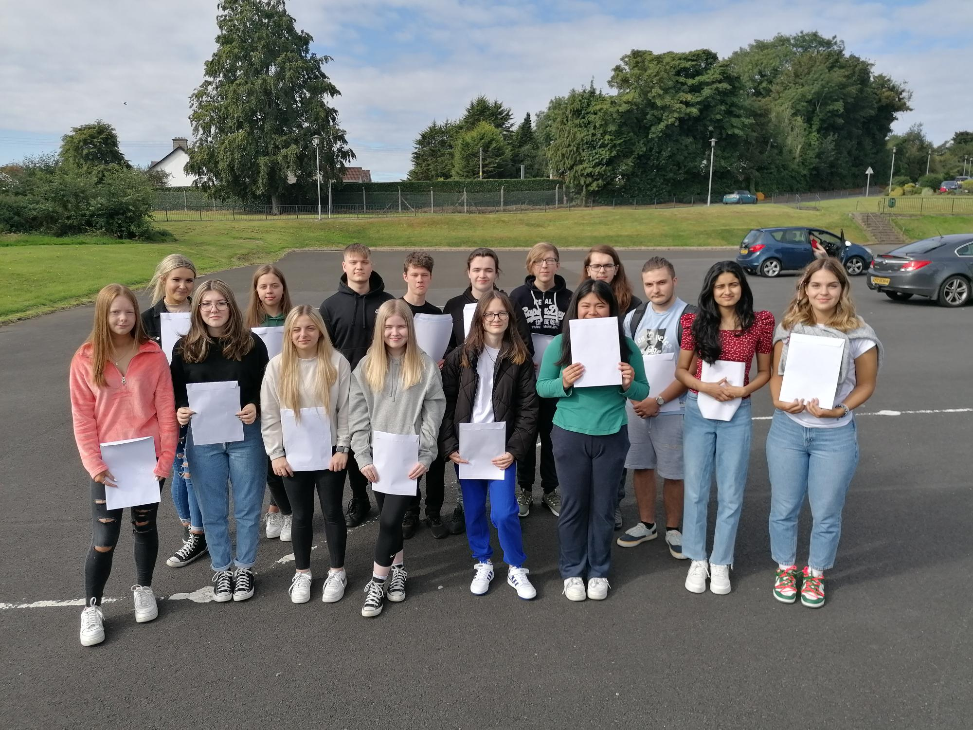
16 of the 21 St Patrick’s College students who have achieved at least TEN GCSEs at A*-C grades

This was the first set of GCSE exams to take place since the onset of the pandemic, and the last year that our Year 12 students had a year uninterrupted by lockdowns or Covid was their second year. This makes their fantastic performance in these GCSE exams all the more remarkable.
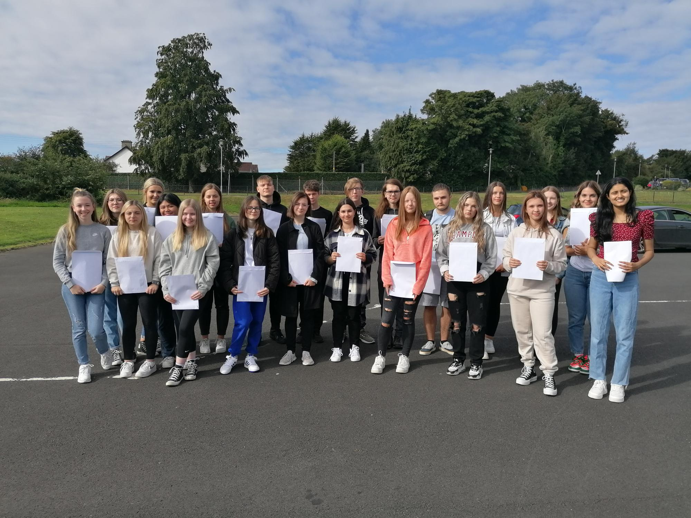
Just some of the St Patrick’s students who have achieved at least eight GCSEs at A*-C

Particular congratulations this year must go to Connor Macauley, who has achieved an amazing ELEVEN GCSEs, all at A*-B grades. Another TWENTY students have achieved ten GCSE passes at A*-C, with a further twenty students achieving between seven and nine GCSE passes, with a significant proportion of all these grades being A* or A.
St Patrick’s College Principal, Dr Martin Knox, with (l-r) Augusteena Augustine and Cristian Pavel. Augusteena and Cristian have achieved two of the school’s highest average scores across all of their GCSE grades, with most of their results achieved at A* or A grade.

Seven subjects – Drama, English Literature, Irish, Polish, Prince’s Trust, OCN Religious Studies and Sport – are celebrating 100% performance at A*-C grades. 95% of ICT grades, 94% of Home Economics (Food & Nutrition), 84% of Art & Design, 82% of Performing Arts and 80% of Construction grades were achieved at A*-C, while other subject areas which have seen A*-C performance of over 70% include Business & Communication Systems, English Language, Home Economics (Child Development), Learning for Life & Work, Religious Studies and Science.

Dr Knox congratulated all of the school’s Year 12 students on their hard work and success. ‘This has been another very demanding year for all of us in education, and these results are the culmination of a great deal of hard work on the parts of both students and teachers. I congratulate all of the students, as well as their teachers, who have worked hard to accurately reflect the ability, effort and success of the students. I would also like to thank the parents of the young people, for the encouragement and support they have provided to their children during the two years of their examinations, and particularly during the difficult circumstances we have had during the pandemic, as our young people coped with the uncertainty of lockdown periods and then readjusted to being back in school.

‘We are proud of the successes of all of our GCSE pupils, who between them in Year 12 have achieved 14 A* grades, 45 A’s, 210 B’s, 104 C* and 116 C grades. These are excellent results from students who, in many cases, had enrolled in St Patrick’s College five years ago with their confidence severely dented by the Transfer procedure.

‘I am sure their achievements will give our GCSE students the confidence and encouragement to go on to further success at A level.

‘I want to recognise the achievement of our students across all courses, including a number of applied courses delivered in school, and also the Occupational Studies courses delivered in the Northern Regional College. The outcomes from all of these courses have been excellent.

‘Overall, these results give us great confidence as a school as we continue to ensure that the students leaving St Patrick’s do so with the highest qualifications they can possibly achieve.

‘We made a decision four years ago to create a Grammar Stream at GCSE level, to give as many as possible of our students the greatest chance of success. Each year, two Form Classes take a programme of ten GCSEs, including Double Award Science and English Literature. We are very pleased that 79% of these students have achieved at least seven GCSE grades at A*-C, and also that 77% of these students have achieved at least five GCSEs at A*-C including English and Maths, against an overall percentage for the Year Group of 48% achieving these grades.’

Dr Knox also praised other successes within the Year 12 group, particularly 28 students who have completed the Prince’s Trust course, gaining a Level Two qualification equivalent to two GCSEs at Grade B. 30 students have successfully completed the OCN Religious Studies course, equivalent to GCSE Grade B. In addition, 15 Level 2 qualifications have been achieved in Occupational Studies, equivalent to GCSEs at A*-C.
Year 12 students celebrating their GCSE results

‘As a non-selective school, we celebrate success at all levels across the full range of ability. These are vocational courses, many of which our students access through the Northern Regional College, and they aim to broaden the educational experience of the young people, with a view to preparing them for further training or apprenticeships. I am delighted that these students have successfully embraced this opportunity, and I would like to thank the staff of the Northern Regional College for the partnership we enjoy, which is obviously benefiting our students.’

Results for last year’s Year 11 students in the GCSE modules they took this Summer are also excellent, and are a very encouraging indicator of continuing success for next year’s GCSE results. Dr Knox congratulated these students on how well they have coped with the transition to Key Stage Four, following the disruptions to their education in Years 9 and 10 caused by the pandemic.

Dr Knox congratulated the Year 11 students on their success and wished them well as they progress to Year 12. He also wished all of the school’s Year 12 students every success in the next stage of their education and looks forward to welcoming most of them back to begin Sixth Form studies in St Patrick’s.

