Excellent results for St Patrick’s College, Ballymena
100% pass rate at A Level!

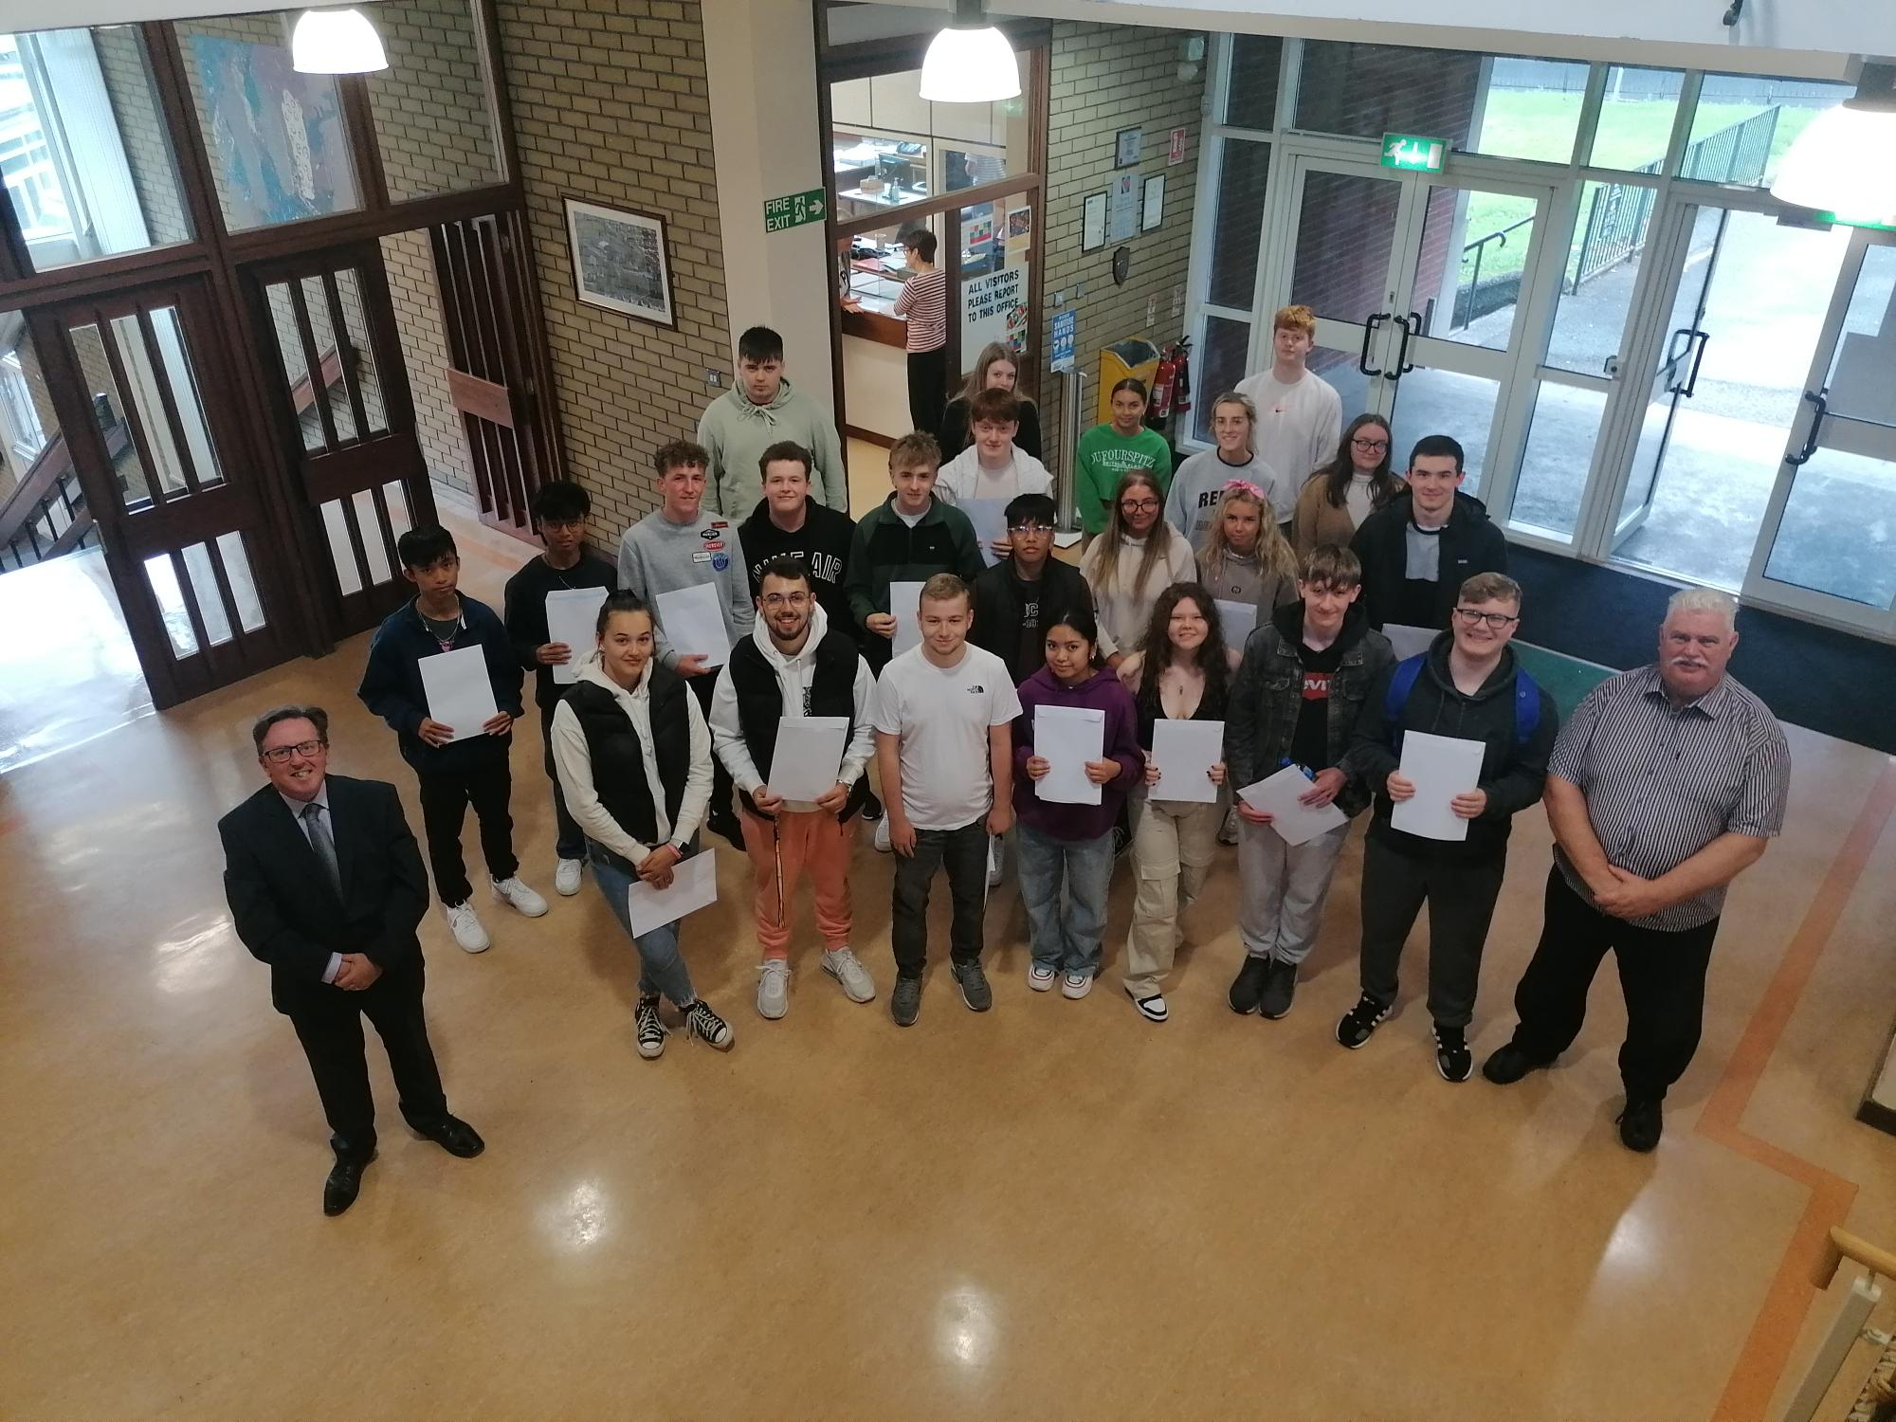
St Patrick’s College Year 13 and 14 students with (l) Vice Principal, Paul Fitzpatrick and (r) Principal, Dr Martin Knox

St Patrick’s College, Ballymena’s Principal Dr Martin Knox this week congratulated his students on the outstanding success they have achieved in their recent GCE results, reflecting the strong commitment of pupils, parents and staff to ensuring that all pupils reach their full potential.

These were the first public examinations for these Year 14 students since Year 11, as examinations did not take place in 2020 or 2021. Dr Knox congratulated the students on their performance this year, three years after they took their last set of public exams.

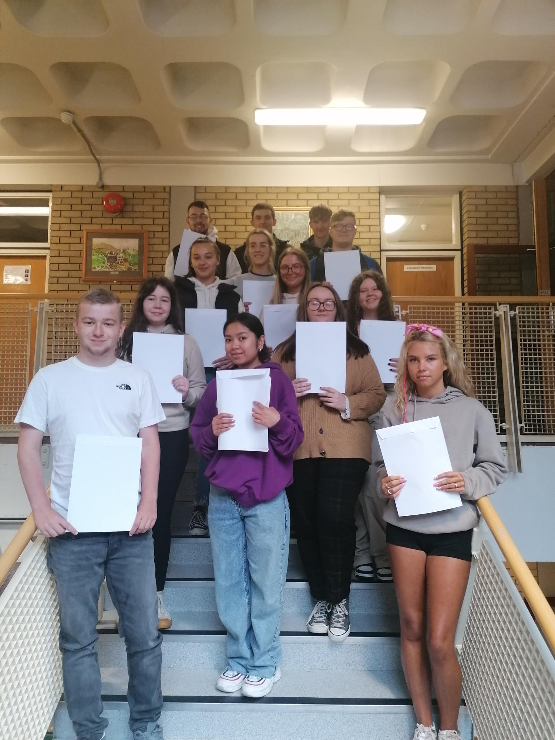
Year 14 students with their A2 results
Overall, St Patrick’s College Sixth Form students have seen great success this year. In total, 15 A or A* grades have been achieved by the College’s Year 14 students, accounting for well over 20% of the total grades obtained by these students.
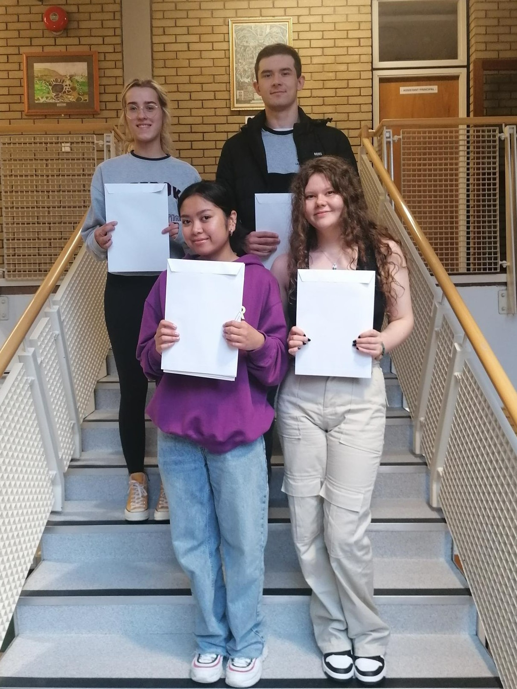
Back row (l-r): Vanesa Meija, Maciej Gawlik and front row (l-r): Ann Dennise Marquez and Caragh Hamill, all of whom have achieved at least one A* and one A grade in their results

37% of the College’s Year 14 students are celebrating at least one A grade in their ‘A’ Level results this week, with 20% also celebrating at least one A* grade.

Further success has been achieved at AS Level, where St Patrick’s students have completed a highly successful first year of their ‘A’ Level courses. This was the first Summer public examinations for these students, who were in Year 11 when the pandemic began.
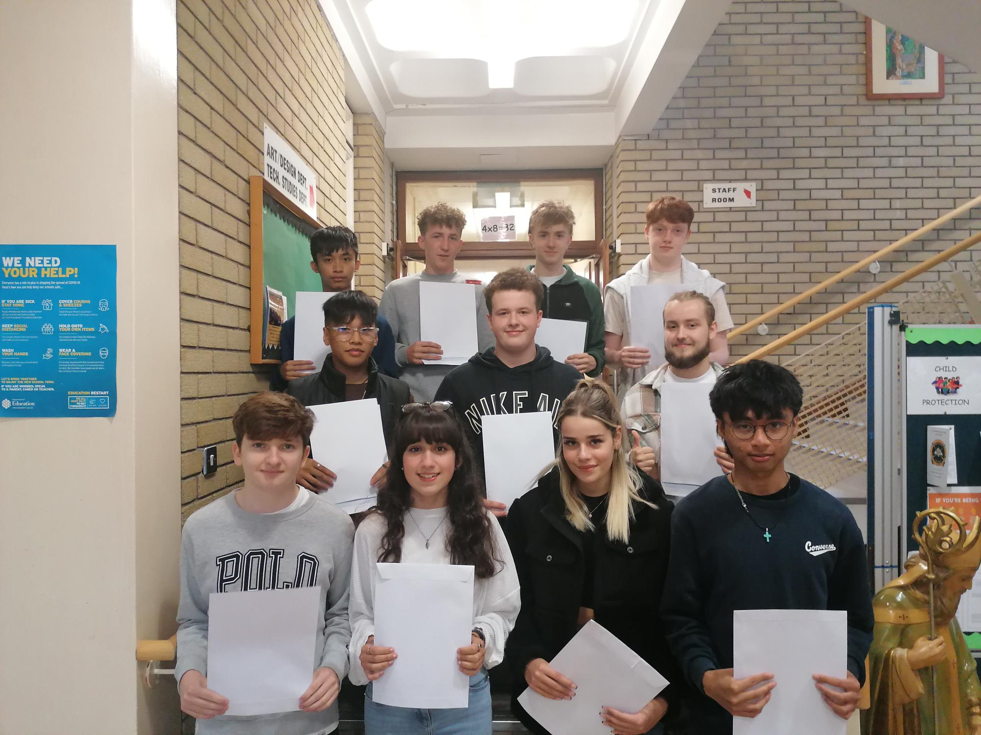
Year 13 students with their AS results

Just under half of all grades achieved at AS Level were at A-B grades, an outstanding achievement on the part of both students and teachers.

St Patrick’s College Principal, Dr Martin Knox, congratulated all of his ‘A’ Level students on their outstanding level of achievement.

‘I am delighted to see so many of our students achieving at this top level and it is testament to the effort that they and their teachers have put into their ‘A’ Level work over the past two years. The last three years have been an extremely unsettling period for young people, but our students’ excellent results are testament to the strong work they had put into their courses, both during their time in school and during the periods of lockdown in 2020 and 2021.

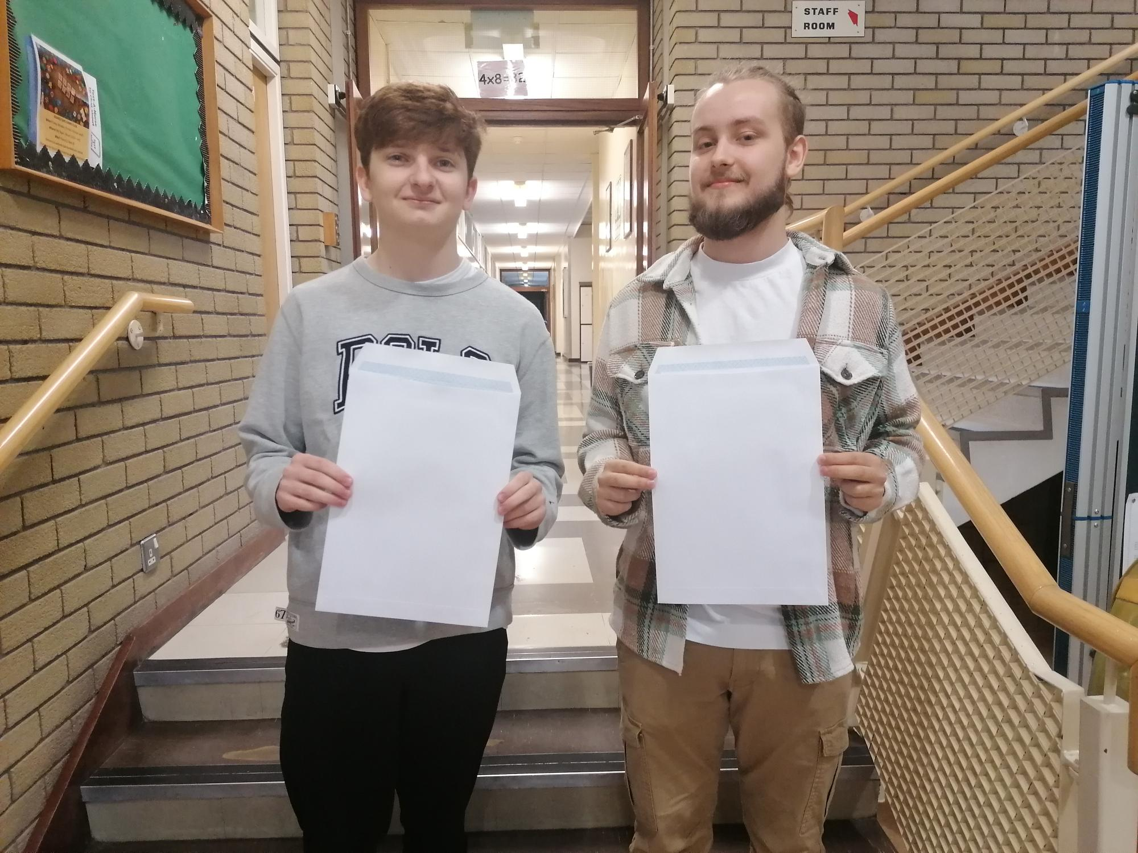
(l-r) Matthew Irvine and Kuba Traczykowski; two of our highest achieving AS students

‘Five of our students have achieved at least two A grades out of their ‘A’ Levels, and I am delighted that we have a 100% pass rate across all of our courses to celebrate. A particular word of congratulation must go to our Art, ICT, Performing Arts and Polish Departments, which all saw 100% of their students achieve grades at A*-C. A high percentage of our Art, ICT and Sport students achieved Distinction or Starred Distinction (A*) grades.

‘We are very pleased that such a significant number of our students have achieved three of their ‘A’ Levels at A*-C, and I am delighted to say that our students have achieved excellent results in both their AS and A2 courses.

‘We have many Sixth Form students who come to us from other schools when they have completed their GCSE courses, and their success at ‘A’ Level shows how well they settle into life here at St Patrick’s. It is notable that some of these students are among our very highest achievers.’

Some of our students also completed courses in collaboration with other local schools or the Northern Regional College, and Dr Knox passed on his congratulations and thanks to those institutions for all they have done to help our students to achieve their full potential.

Dr Knox congratulated and thanked his staff for the support, guidance and advice they have given the school’s young people during their ‘A’ Level studies. He further congratulated the students’ parents, who have provided unfailing support to their children during this very busy two year period, and particularly during the periods of lockdown in 2020 and 2021.

‘The very high level of success achieved by our Year 13 students in the first year of their ‘A’ Level programmes gives them every encouragement to go on and achieve further success next year in their A2 year.’

Onward destinations for this year’s A2 students include Queen’s University, Belfast for Computer Science, Ulster University for degrees including Psychology, Fine Art, Early Childhood Education, and Computing, and Liverpool John Moores University for degrees in Forensic Psychology and Criminal Justice, Graphic Design and Illustration, and Sports Coaching.

Dr Knox wished the Sixth Form students who will be leaving the College this year every success in the future as they move on to Further and Higher Education and into the world of work. He thanked them for the outstanding contribution they have made to the school, and also for the example they have given younger pupils at St Patrick’s, through their excellent academic performance, their work as Pupil Mentors to the younger pupils and the many other ways in which they have taken part in the life of the school. Undoubtedly they have followed the school’s Mission Statement of living and practising their faith and their commitment to one another. He said, ‘They have been outstanding role models to the other pupils and exemplary young people, and we at St Patrick’s College wish all of them every success in the future.’

