12th May 2020
Dear Parent/Guardian
We wrote to parents of students in Years 11 to 14 on 20th April, with details of CCEA’s plans for the awarding of grades this Summer. We are circulating along with this letter a message from CCEA for students regarding the awarding of grades this Summer. I would urge you to read this notice carefully.
We will continue to support our students and our school community as best we can, both pastorally and academically during these challenging times.
Our advice to all of our students is as follows:
- Keep in contact with your subject teachers through their Google Classrooms
- Continue to keep school work as part of your daily routine, to maintain good working habits
- Years 11 to 14, please continue with the work being set by your teachers, to enable the full course you are studying to be covered. This is important to ensure there are no gaps in your learning and knowledge as you progress beyond this year.
- Years 11 and 13 will complete this year’s work before moving onto next year’s work. This ensures that any student who wishes to sit Year 11 or Year 13 exams next year will have covered the full course.
- Teachers will continue to set work for students until the week ending 19th June.
- Students in Years 8, 9 and 10 should continue to engage with the tasks set by their teachers, again to make sure that they do not have gaps in their learning when they progress to the next Year Group.

I would ask any family that is having difficulty with our online learning to contact Mr Fitzpatrick at pfitzparick867@c2ken.net . If any student has any pastoral issues, I would ask them to contact Mrs Harkins at charkins282@c2ken.net . Any other queries or issues should be directed to info@stpatricks.balllymena.ni.sch.uk .
We will contact parents again as soon as we receive any guidance from the Department of Education on schools re-opening.
Finally, I would like to wish all of our students and their families well, and I hope that you all keep well, stay safe and stay at home.
Yours faithfully
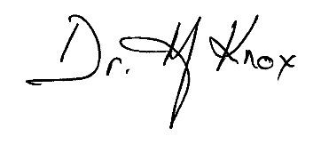
Dr Martin Knox
Principal

