16th March 2021

Dear Parent/Guardian
Letter to Parents/Guardians of students in Years 8 to 11
I hope you and your family are all keeping well.
I would like to take this opportunity to congratulate our students in Years 8, 9, 10 and 11 on their engagement with remote learning during the current lockdown period.
As you will be aware, students in Years 12, 13 and 14 will be returning to school from Monday 22nd March. Following today’s meeting of the Northern Ireland Executive, it is anticipated that students in Years 8 to 11 will return to school immediately after the Easter holiday, on Monday 12th April, although this will be subject to a further review of the public health situation nearer that date. We will be in touch with you again when the return date has been confirmed.
Year 10 students have now submitted their Free Choice selections for GCSE options, and we are currently processing these options. We will be using this information to build subject blocks, and we will then be asking Year 10 students to make choices from these blocks.
Remote learning for this term will end on Tuesday 30th March, as Wednesday 31st March will be a Staff Development Day, for teachers to work on the collation of evidence for Centre Determined Grades for this year’s GCSE and GCE grades. We wish all of our students and their families a happy and holy Easter holiday.
On behalf of our teaching staff and myself, I thank you, our parents/guardians, for your continuing support during this period of remote learning, and we look forward to seeing our Year 8, 9, 10 and 11 students return to school in the near future.

Yours faithfully
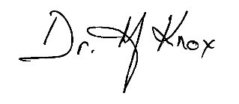
Dr Martin Knox
Principal

