St Patrick’s College, Ballymena
50% of Year 14 students achieve at least one A* grade!

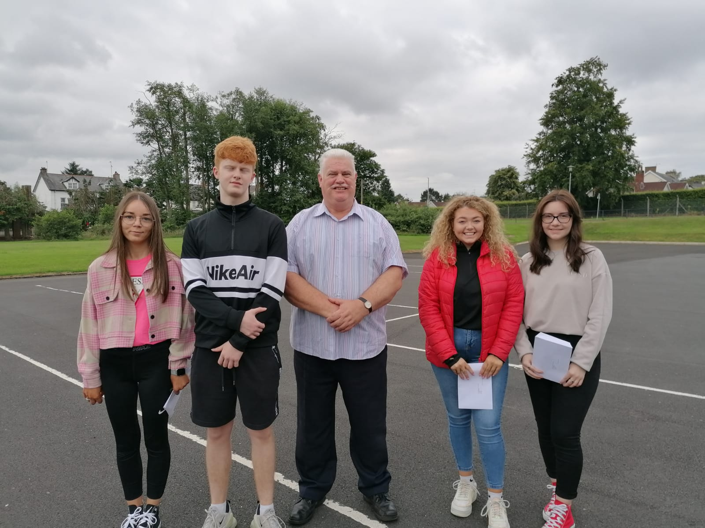
St Patrick’s Principal Dr Knox with (l-r) Bronagh McAuley, Shane Kearney, Emily Hughes and Daria Barbu

St Patrick’s College, Ballymena’s Principal Dr Martin Knox this week congratulated his students on the outstanding success they have achieved in their recent GCE results, reflecting the strong commitment of pupils, parents and staff to ensuring that all pupils reach their full potential.

Public examinations could not take place this year, owing to the Covid-19 lockdown. Students’ grades for AS and A2 qualifications were arrived at through a rigorous process of Centre Determined Grades, looking at previous performance of the students in module exams, performance in CCEA assessments taken between April and June this year, tracking assessments, and also performance in other tasks completed during their courses.

Overall, St Patrick’s College Sixth Form students have seen great success this year. In total, 29 A or A* grades have been achieved by the College’s Year 14 students, accounting for over 40% of the total grades obtained by these students.

77% of the College’s Year 14 students are celebrating at least one A grade in their ‘A’ Level results this week, with 50% also celebrating at least one A* grade.

Further success has been achieved at AS Level, where St Patrick’s students have completed a highly successful first year of their ‘A’ Level courses.
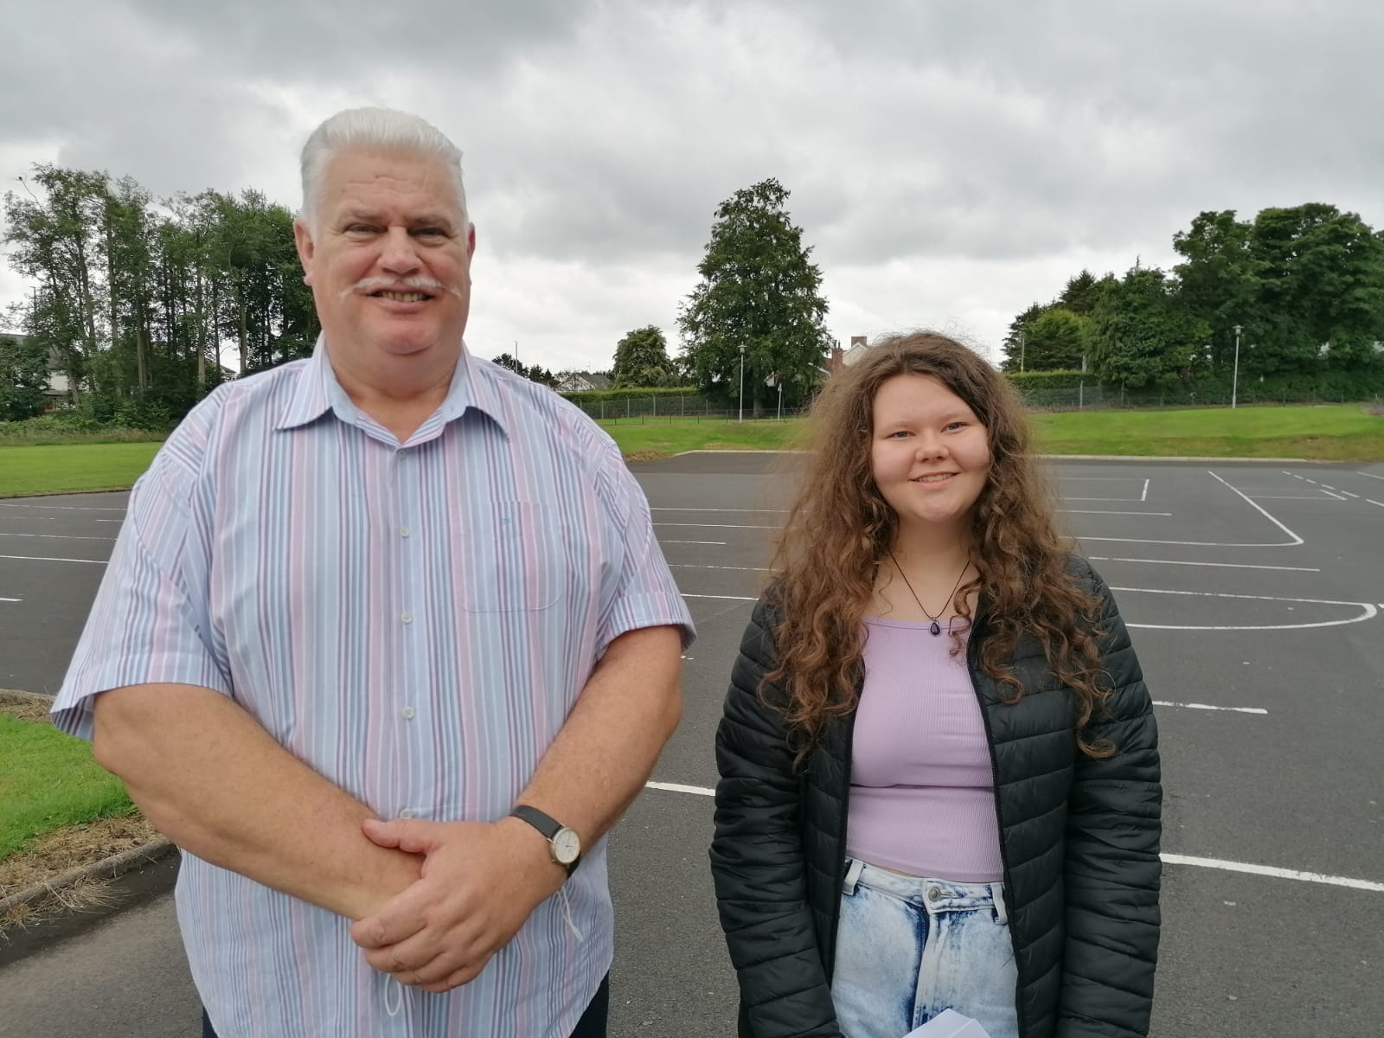
Dr Knox with Caragh Hamill, who has achieved four A grades at AS level
Over half of all grades achieved at AS Level were at A*-B grades, an outstanding achievement on the part of both students and teachers.

St Patrick’s College Principal, Dr Martin Knox, congratulated all of his ‘A’ Level students on their outstanding level of achievement.

‘I am delighted to see so many of our students achieving at this top level and it is testament to the effort that they and their teachers have put into their ‘A’ Level work over the past two years. This has been an extremely unsettling two year period for young people, but our students’ excellent results are testament to the strong work they had put into their courses, both during their time in school and during the periods of lockdown.
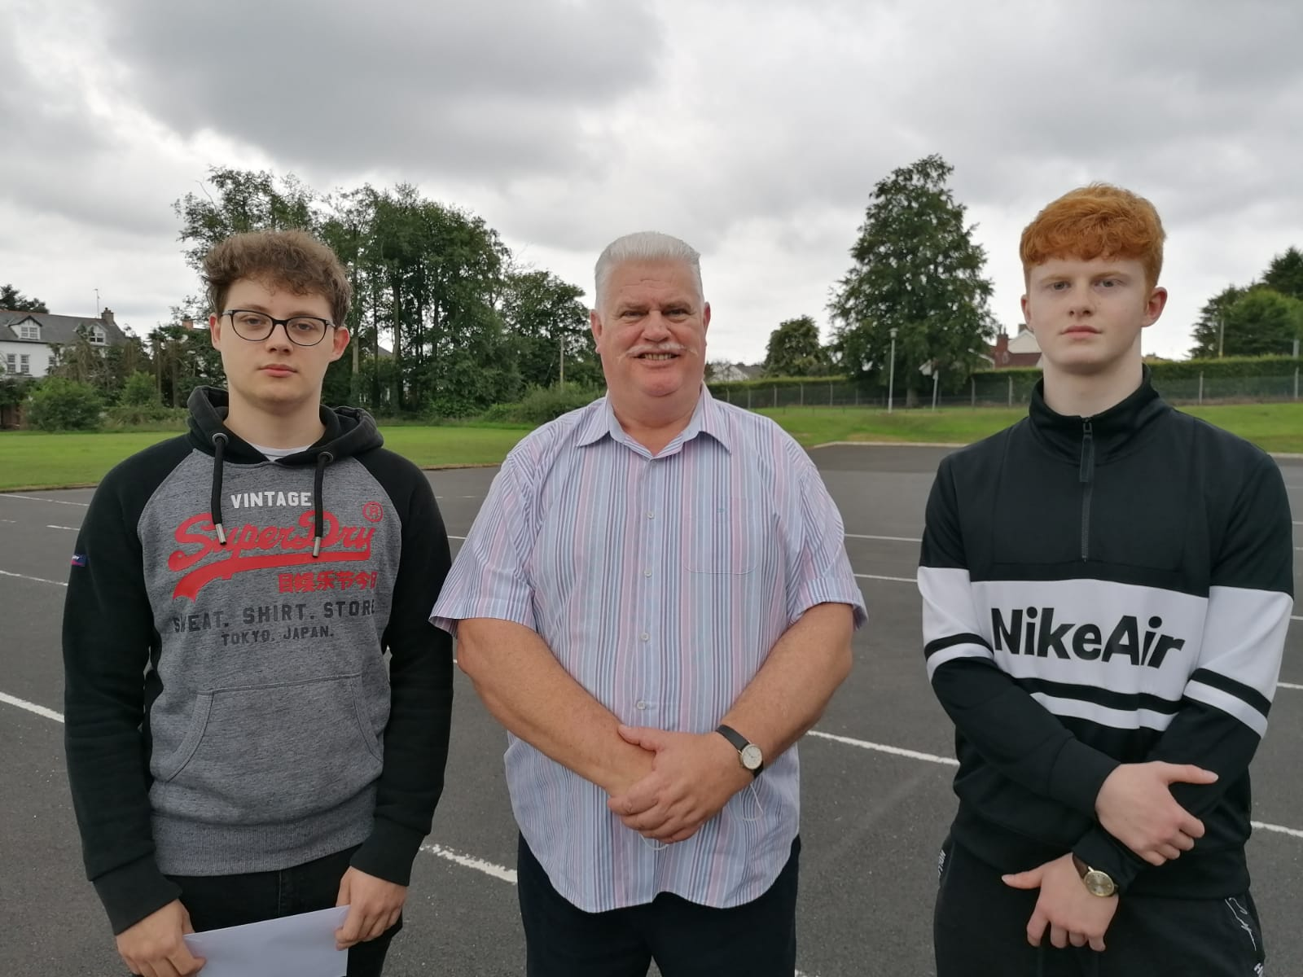
Dr Knox with Jakub Bojanowski and Shane Kearney, who have both achieved three A Levels at A*/A grades

‘Eight of our students have achieved at least two A grades out of their ‘A’ Levels, and I am delighted that we have a 100% pass rate across many of our courses to celebrate. A particular word of congratulation must go to our Art, Construction, ICT, Performing Arts, Polish, Religious Studies and PE Departments, which all saw 100% of their students achieve grades at A*-C. All Year 14 Sport students achieved Distinction or Starred Distinction grades. A high percentage of our Art, ICT and Construction students achieved a Starred Distinction (A*) grade.

‘We are very pleased that such a significant number of our students have achieved three of their ‘A’ Levels at A*-C, and I am delighted to say that our students have achieved excellent results in both their AS and A2 courses.

‘We have many Sixth Form students who come to us from other schools when they have completed their GCSE courses, and their success at ‘A’ Level shows how well they settle into life here at St Patrick’s. It is notable that some of these students are among our very highest achievers.’

Dr Knox congratulated and thanked his staff for the support, guidance and advice they have given the school’s young people during their ‘A’ Level studies. He further congratulated the students’ parents, who have provided unfailing support to their children during this very busy two year period, and particularly during the periods of lockdown.

‘The very high level of success achieved by our Year 13 students in the first year of their ‘A’ Level programmes gives them every encouragement to go on and achieve further success next year in their A2 year.’
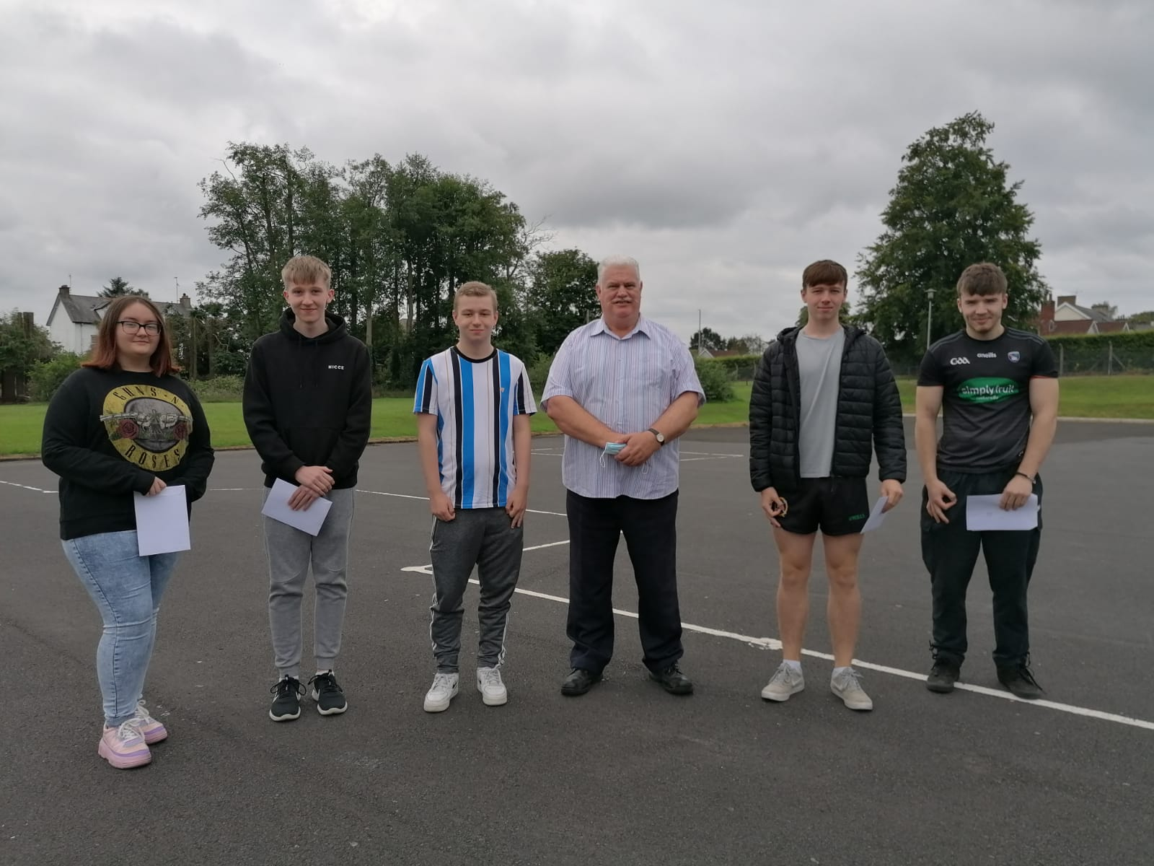
Dr Knox with Year 13 students (l-r) Kiara Hutchinson, Jack Hamill, Calum Morrison, Jude Casey and Joshua Blair

Dr Knox wished the Sixth Form students who will be leaving the College this year every success in the future as they move on to Further and Higher Education and into the world of work. He thanked them for the outstanding contribution they have made to the school, and also for the example they have given younger pupils at St Patrick’s, through their excellent academic performance, their work as Pupil Mentors to the younger pupils and the many other ways in which they have taken part in the life of the school. Undoubtedly they have followed the school’s Mission Statement of living and practising their faith and their commitment to one another. He said, ‘They have been outstanding role models to the other pupils and exemplary young people, and we at St Patrick’s College wish all of them every success in the future.’

