Excellent results for St Patrick’s College, Ballymena
A Level students
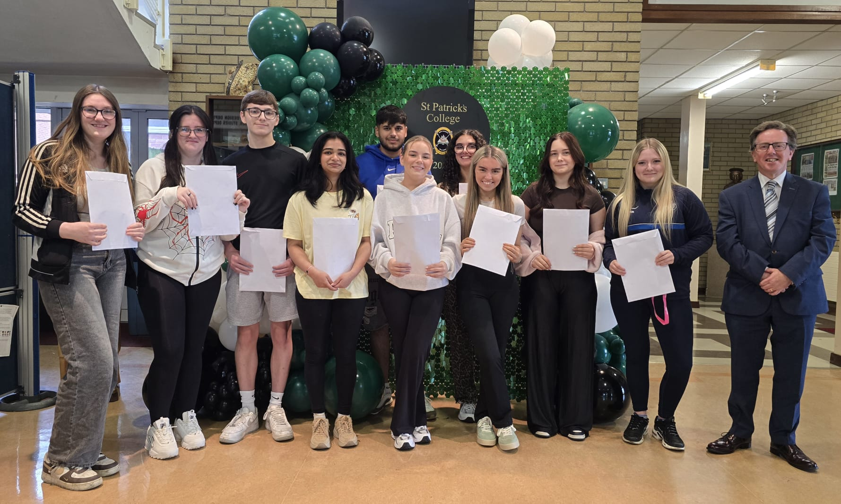
Year 14 students celebrating their exam results with Mr Fitzpatrick

St Patrick’s College, Ballymena’s Principal Paul Fitzpatrick this week congratulated his students on the outstanding success they have achieved in their recent GCE results, reflecting the strong commitment of pupils, parents and staff to ensuring that all pupils reach their full potential.

Overall, St Patrick’s College Sixth Form students have seen great success this year. In total, 13 A or A* grades have been obtained by the College’s Year 14 students, accounting for 21% of the total grades obtained by the Year Group. Top results in the school include Keelan McManus who has gained three A grades, along with two others who have achieved at least two A grades. In total, 38% of students have got at least one A grade in their results, and the percentage of students achieving three A Levels at A*-C has increased by 4% from last year. A significant number of grades – over 70% – have been at A* to C.
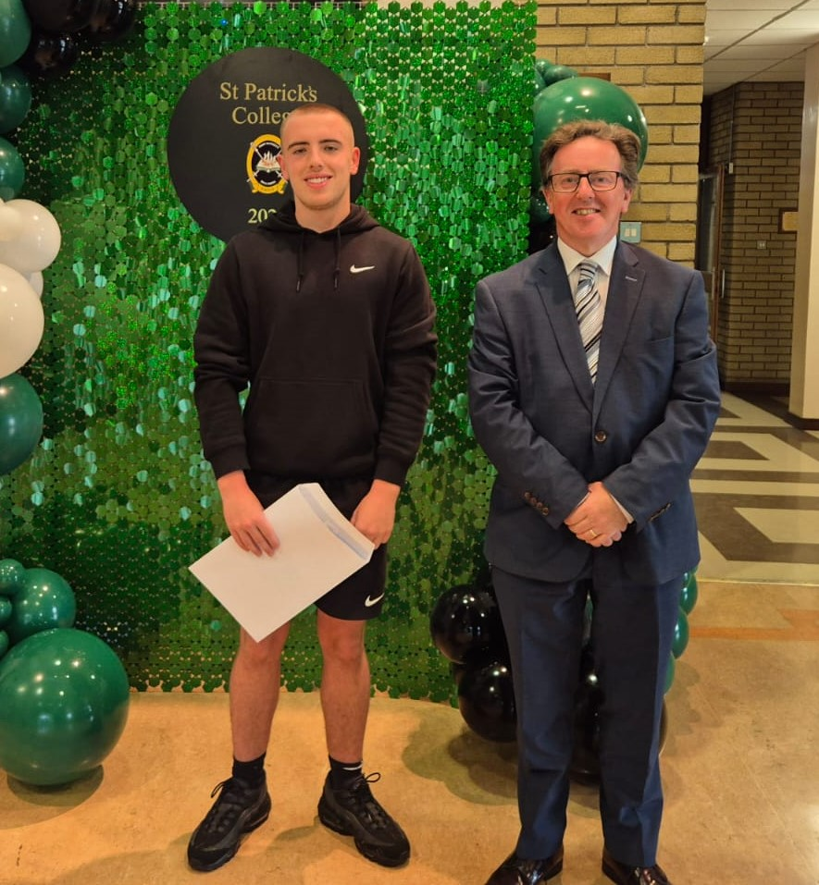
Mr Fitzpatrick with Keelan McManus, who has achieved three A grades in his A Levels

Further success has been achieved at AS Level, where St Patrick’s students have completed a highly successful first year of their ‘A’ Level courses, which will help them reach further success in their A2 results next Summer. Here, 81% of grades obtained in AS examinations have been at the A*-C level, with one very successful student achieving two A grades and two B grades.
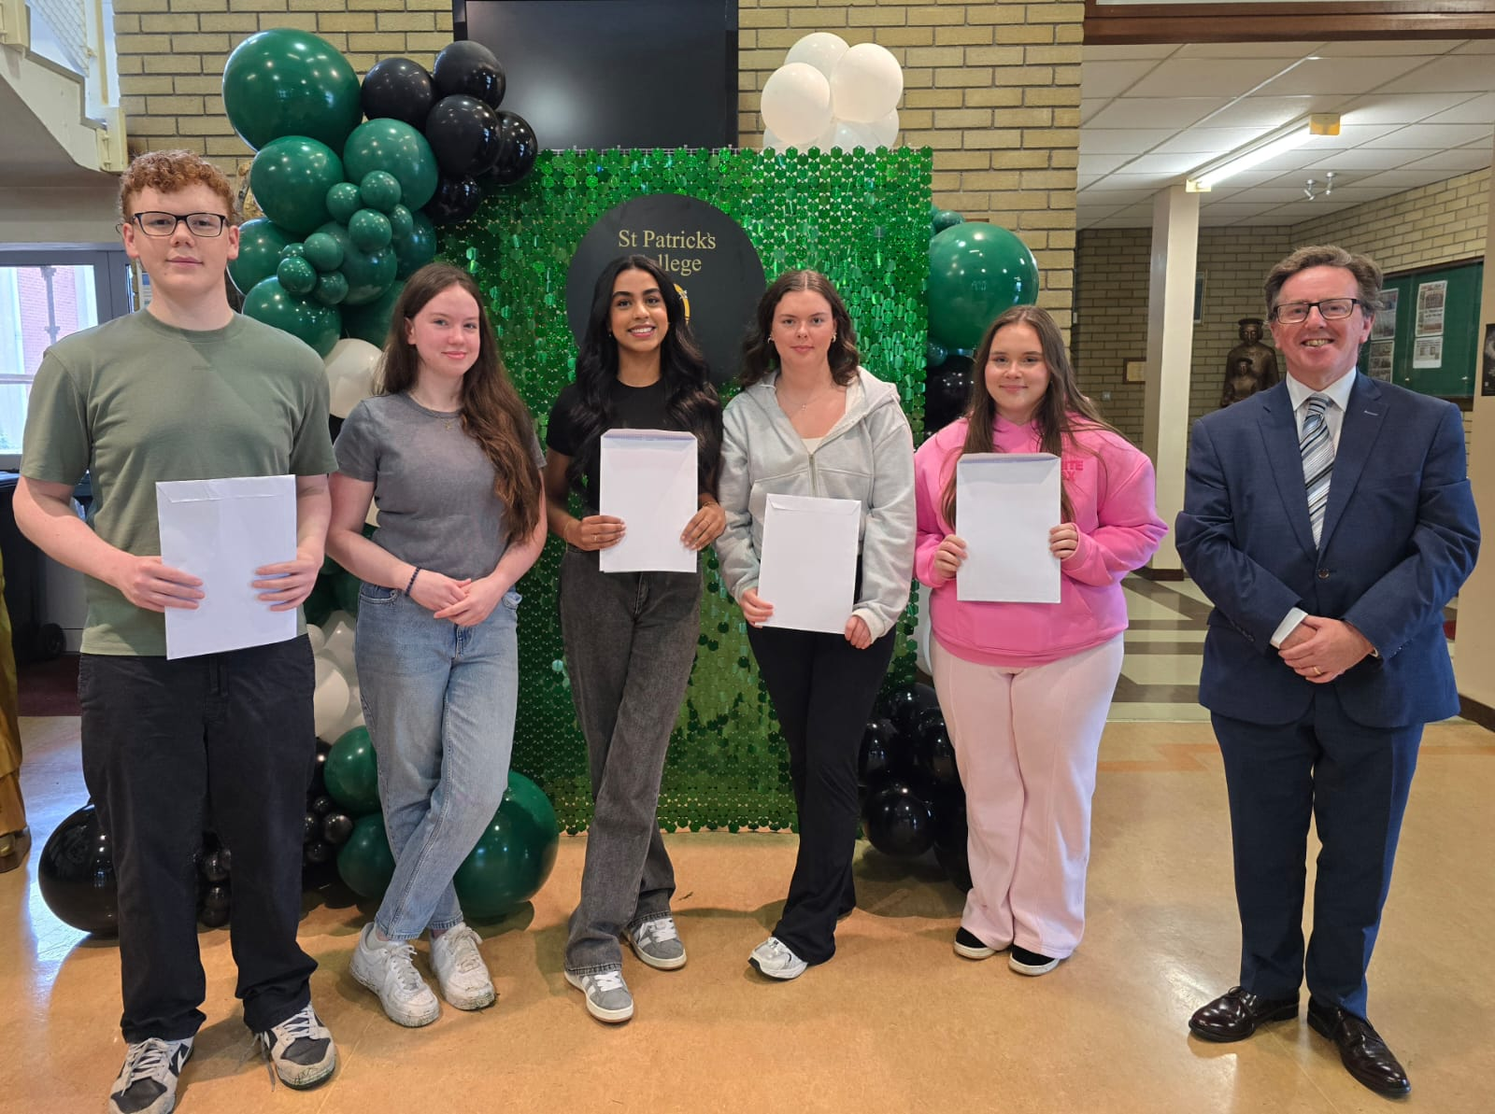
Mr Fitzpatrick, with some of the Lower Sixth students who are celebrating excellent AS results

St Patrick’s College Principal, Paul Fitzpatrick, congratulated all of the school’s ‘A’ Level students on their outstanding level of success.

‘I am delighted to see so many of our students achieving at this level and it is testament to the effort that they and their teachers have put into their ‘A’ Level work over the past two years. The last six years have been an extremely unsettling period for young people, but our students’ excellent results are testament to the strong work they have put into their courses.

‘Many of our students have got at least one A grade out of their ‘A’ Levels, and I am delighted with our students’ overall high level of success. A particular word of congratulation must go to our Art students, 86% of whose marks were at Distinction (A) or Starred Distinction (A*) level, and to our Polish, Religious Studies and Sports Departments, which saw 100% of their students achieve grades at A*-C. Meanwhile, results across other Departments also continued to increase this year.
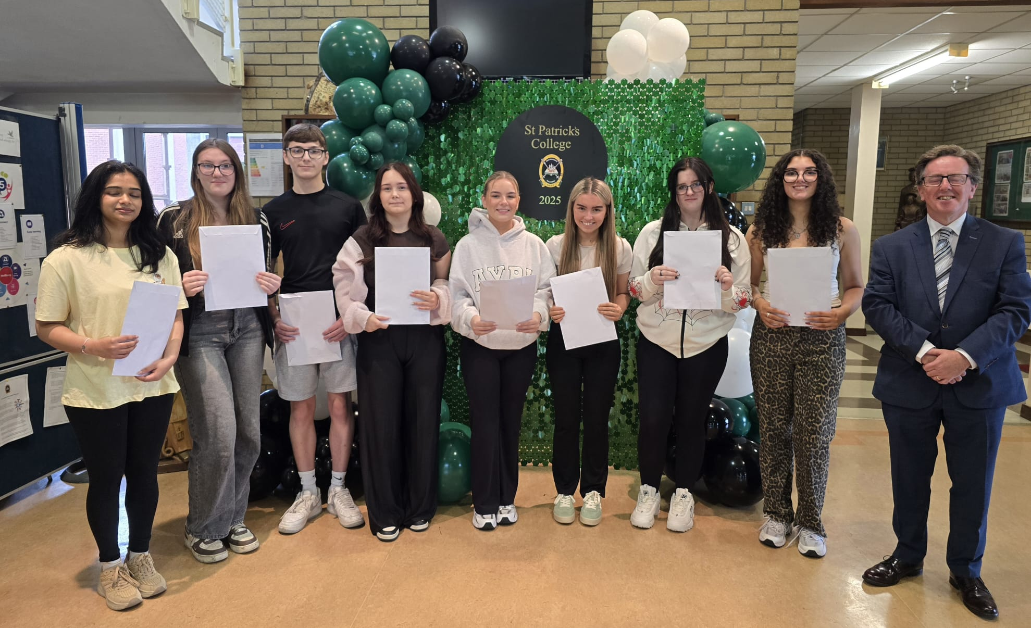
Some of the Upper Sixth students who have achieved three A Levels at grades A* to C
‘We are very pleased that such a significant number of our students have achieved three of their ‘A’ Levels at A*-C, and I am delighted to say that our students have excellent results in both their AS and A2 courses.

‘We have many Sixth Form students who come to us from other schools when they have completed their GCSE courses, and their success at ‘A’ Level shows how well they settle into life here at St Patrick’s College. It is notable that some of these students are among our very highest achievers.’

Some of our students also completed courses in collaboration with other local schools or the Northern Regional College, and Mr Fitzpatrick passed on his congratulations and thanks to those institutions for all they have done to help our students to reach their full potential.
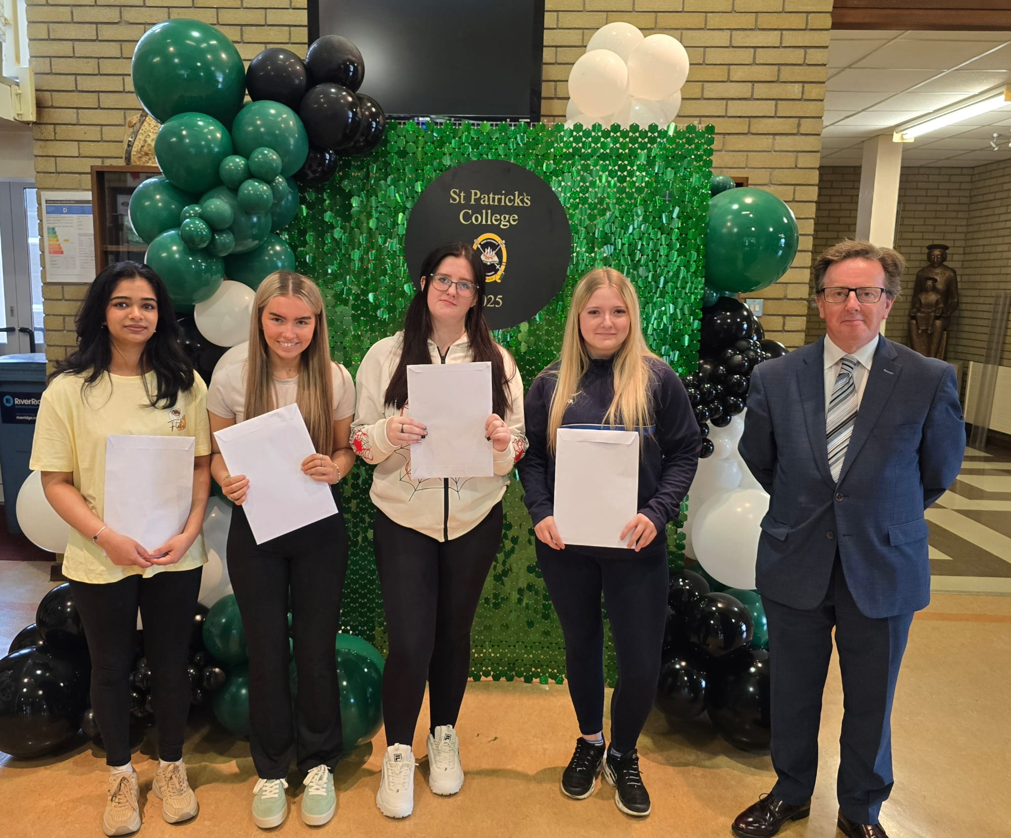
Some of the Upper Sixth students who have achieved at least one A grade in their A Levels

Mr Fitzpatrick congratulated and thanked the school’s staff for the support, guidance and advice they have given the school’s young people during their ‘A’ Level studies. He further congratulated the students’ parents, who have provided unfailing support to their children during this very busy two year period.

‘The high level of success achieved by our Year 13 students in the first year of their ‘A’ Level programmes gives them every encouragement to go on and enjoy further success next year in their A2 year.’

Onward destinations for this year’s A2 students include:
- Ulster University for degrees in Accounting and Finance, Journalism, Sociology with Criminology and Sport, Physical Activity and Health
- Stranmillis University College for Early Childhood Studies
- Bournemouth University for International Tourism and Hospitality
- Derby University for Occupational Therapy
- Liverpool Hope University for Accounting & Finance and Business

Mr Fitzpatrick wished the Sixth Form students who will be leaving the College this year every success in the future as they move on to Further and Higher Education and into the world of work. He thanked them for the outstanding contribution they have made to the school, and also for the example they have given younger pupils at St Patrick’s College, through their excellent academic performance, their work as Pupil Mentors to the younger pupils and the many other ways in which they have taken part in the life of the school. Undoubtedly they have followed the school’s Mission Statement of living and practising their faith and their commitment to one another. He said, ‘They have been outstanding role models to the other pupils and exemplary young people, and we at St Patrick’s College wish all of them every success in the future. They will very much continue to be a part of our school community as they move forward to an exciting new chapter in their lives.’

