St Patrick’s College, Ballymena
23 Year 12 students achieve 10 or more GCSEs each!

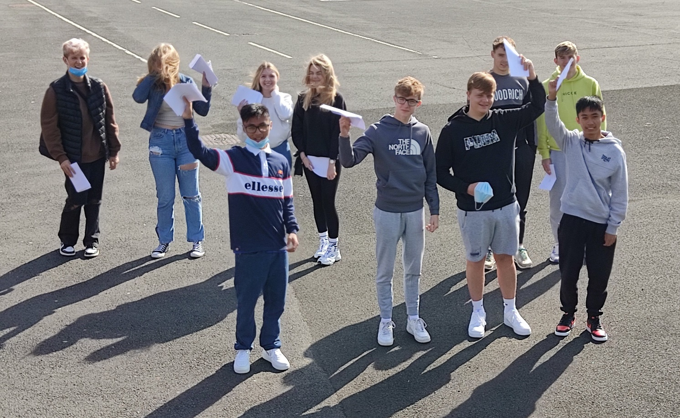
St Patrick’s students celebrating their GCSE results (l-r): Jakub Pluta, Maja Matuszkiewicz, John Viado, Lea Kinney, Natalia Miscikova, Aidan McWhinney, Kasper Dziadkowiec, Rhys Wright,
Cal O’Brien and James Viado

St Patrick’s College, Ballymena had a second day of celebrations on Thursday of last week, when Year 12 students achieved the best-ever GCSE results in the College.

Particular congratulations this year must go to two Year 12 students, Maja Matuszkiewicz and Jakub Pluta, who have both achieved an amazing ELEVEN GCSEs at A*-C. A further TWENTY ONE students have achieved ten GCSE passes at A*-C, and nineteen more students have achieved at least seven GCSE passes, with a significant proportion of their grades being A* or A.

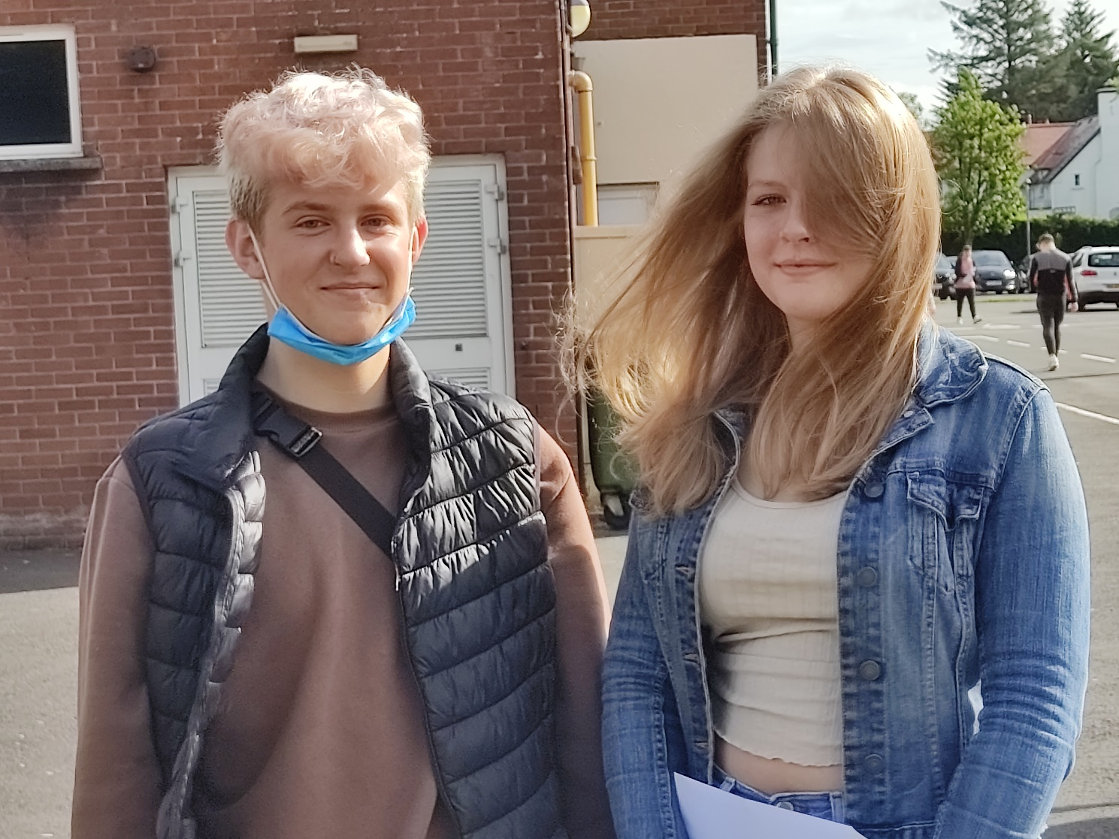
Jakub Pluta and Maja Matuszkiewicz, who have both achieved eleven GCSE grades at A*-C

The Polish Department is celebrating 100% performance at A* or A grades. There has also been particular success in Drama, Music, Performing Arts, OCN Religious Studies and Physical Education, in all of which 100% of candidates have achieved A to C grades. 96% of History and ICT grades, 90% of Child Development, 88% of Learning for Life & Work and Religious Studies, and 87% of English Literature grades were achieved at A*-C, while other subject areas which have seen A*-C performance of over 80% include Art & Design, and Home Economics.

As with A Level grades, this year’s GCSE results were arrived at through a rigorous process of Centre Determined Grades, looking at previous performance of the students in module exams, performance in CCEA assessments taken between April and June this year, tracking assessments, and also performance in Controlled Assessment tasks completed during their courses.
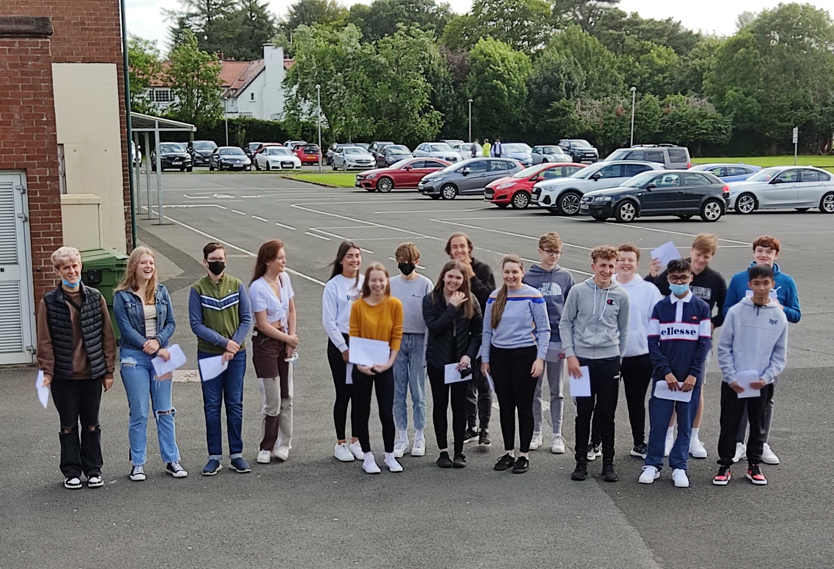
Some of the St Patrick’s students who have achieved at least ten GCSE grades at A*-C (l-r): Jakub Pluta, Maja Matuszkiewicz, Mykolas Brazauskas, Megan Anderton, Hannah O’Kane, Dominika Nowak, Ruairi Diamond, Clodagh McIlwee, Kacper Krolik, Naomi Gordon, Aidan McWhinney, Eoin Mitchell, Corey Mitchell, John Viado, Kacper Dziadkowiec, James Viado and Finn Roger

Dr Knox congratulated all of the school’s Year 12 students on their hard work and success. ‘Like last year, this has been a very demanding year for all of us in education, and these results are the culmination of a great deal of hard work on the parts of both students and teachers. I congratulate all of the students, as well as their teachers, who have worked hard to accurately reflect the ability, effort and success of the students. I would also like to thank the parents of the young people, for the encouragement and support they have provided to their children during the two years of their examinations, and particularly during the difficult circumstances of 2021, as our young people coped with the uncertainty of a further lockdown period and then readjusted to being back in school.
‘We are proud of the successes of all of our GCSE pupils, who between them have achieved 20 A* grades, 76 A’s, 193 B’s, 87 C* and 158 C grades. These are excellent results from students who, in many cases, had enrolled in St Patrick’s College five years ago with their confidence severely dented by the Transfer procedure.

I am sure their achievements will give our GCSE students the confidence and encouragement to go on to further success at A level.

‘I want to recognise the achievement of a number of our Polish students, ten of whom have achieved an A* grade in GCSE Polish, a qualification which will be very useful to them should they return to Poland to continue their studies or seek employment.

‘Overall, these results give us great confidence as a school as we continue to ensure that the students leaving St Patrick’s do so with the highest qualifications they can possibly achieve.

‘We made a decision three years ago to create a Grammar Stream at GCSE level, to give as many as possible of our students the greatest chance of success. Each year, two Form Classes take a programme of ten GCSEs, including Double Award Science and English Literature. We are very pleased that 78% of these students have achieved at least seven GCSE grades at A*-C, and also that 73% have achieved at least five GCSEs at A*-C including English and Maths.’

Dr Knox also praised other successes within the Year 12 group, particularly twelve students who have completed the Prince’s Trust course, gaining a Level Two qualification equivalent to two GCSEs at Grade B. In addition, 22 students have achieved Level 2 qualifications in Occupational Studies, equivalent to GCSEs at A*-C.

‘As a non-selective school, we celebrate success at all levels across the full range of ability. These are vocational courses, many of which our students access through the Northern Regional College, and they aim to broaden the educational experience of the young people, with a view to preparing them for further training or apprenticeships. I am delighted that these students have successfully embraced this opportunity, and I would like to thank the staff of the Northern Regional College for the partnership we enjoy, which is obviously benefiting our students.’

Dr Knox wished all of the school’s Year 12 students success in the next stage of their education and looks forward to welcoming many of them back to begin Sixth Form studies in St Patrick’s.

