St Patrick’s College, Ballymena
34 students achieve 7 or more GCSEs each!
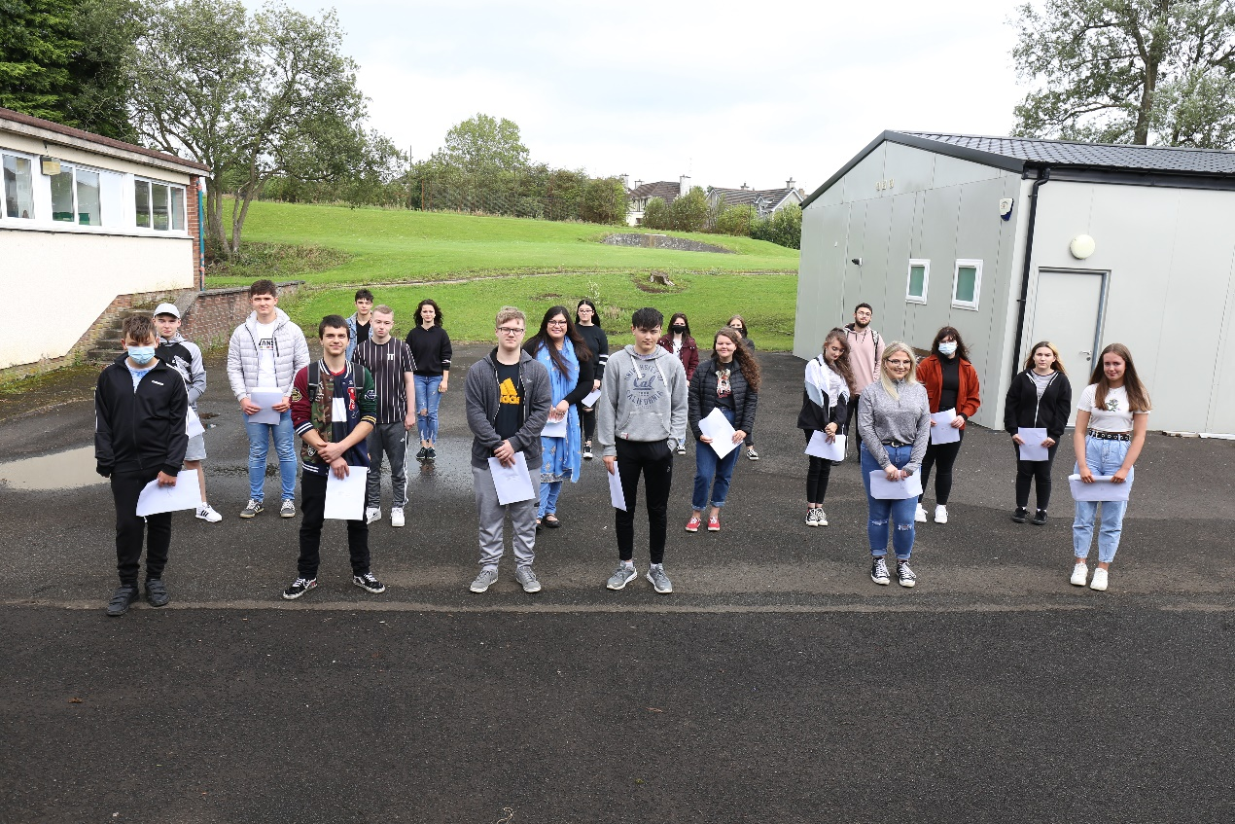
St Patrick’s College GCSE students celebrating their excellent GCSE results

St Patrick’s College, Ballymena’s Principal Dr Martin Knox today congratulated his students on the outstanding success they have achieved in their recent GCSE results, reflecting the strong commitment of pupils, parents and staff to ensuring that all pupils reach their full potential.

GCSE examinations could not take place this year, owing to the Covid-19 lockdown. Students’ grades were arrived at through a rigorous process of Centre Assessed Grading, looking at previous performance of the students in GCSE module exams, performance in mock GCSE exams and other tracking assessments, and also performance in Controlled Assessment tasks completed before schools closed in March.
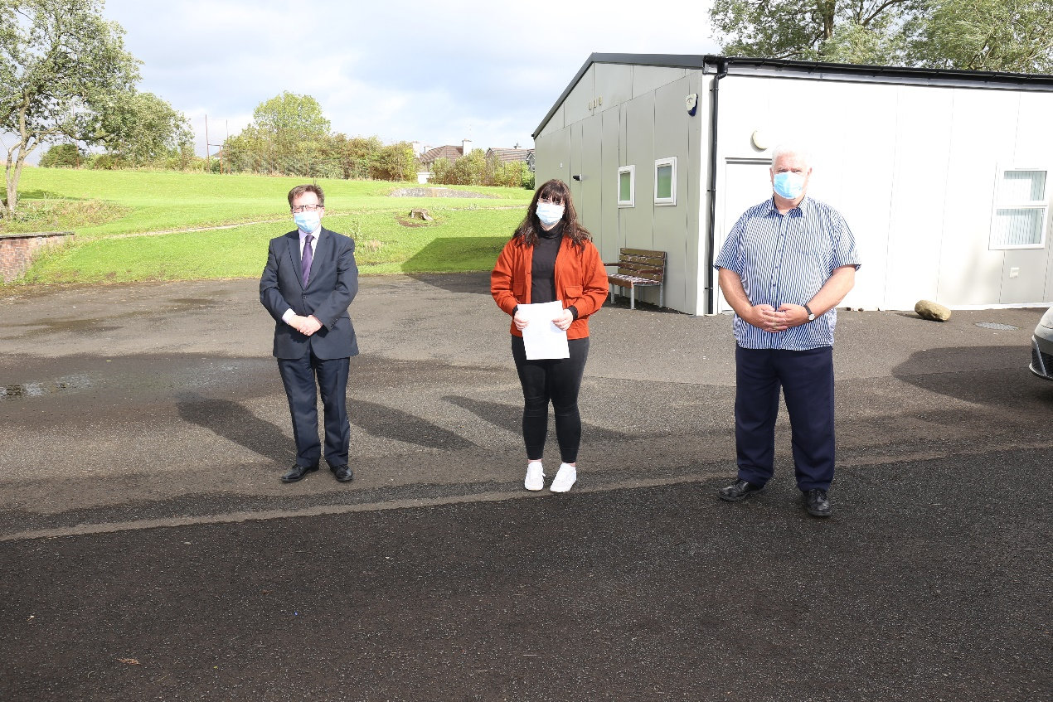
GCSE student Matylda Rejus with Principal Dr Martin Knox (right) and Vice Principal Paul Fitzpatrick (left).

Particular congratulations must go to Matylda Rejus, who after just two years in an English-speaking school has achieved an amazing ELEVEN GCSEs, all at A* and A grades. A further TEN students have achieved ten GCSE passes at A*-C, and seven more students have achieved nine GCSE passes, with a significant proportion of their grades being A* or A.
Emily Hughes (left) and Daria Barbu (right), who have both achieved nine GCSE grades at A*-C

The Polish Department is celebrating 100% performance at A* or A grades. There has also been particular success in Music, Physical Education and OCN Science and Personal & Well-Being courses, where 100% of candidates have achieved A to C grades. 93% of English Literature and 92% of Learning for Life & Work grades were achieved at A*-C, while other subject areas which have seen A*-C performance of over 80% include Art & Design, Construction, History and Home Economics. All students who took the Prince’s Trust Programme have achieved two Grade Bs.

Dr Knox congratulated all of the school’s Year 12 students on their hard work and success. ‘This has been a very demanding year for all of us in education, and these results are the culmination of a great deal of hard work on the parts of both students and teachers. I congratulate all of the students, as well as their teachers, who have worked hard to accurately reflect the ability, effort and success of the students. I would also like to thank the parents of the young people, for the encouragement and support they have provided to their children during the two years of their GCSE examinations, and particularly during the difficult circumstances of the past five months as our young people coped with the uncertainty of the lockdown period.

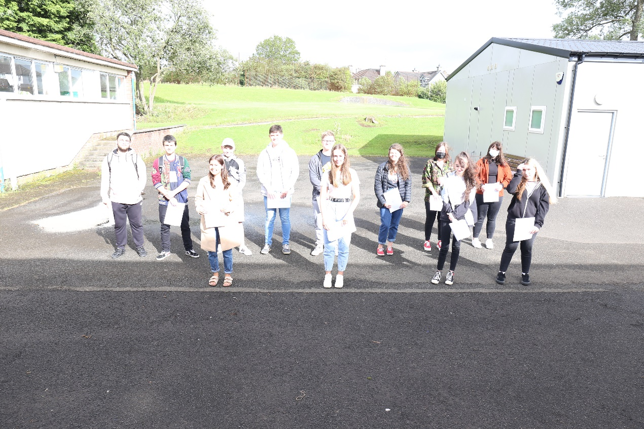
Just some of the 34 students who achieved at least seven A*-C grades in their GCSE results this year.

‘We are proud of the successes of all of our pupils, who between them have achieved 18 A* grades, 75 A’s, 129 B’s, 73 C* and 157 C grades. These are excellent results from children who, in many cases, had enrolled in St Patrick’s College five years ago with their confidence severely dented by the Transfer procedure. I am sure their achievements will give them the confidence and encouragement to go onto further success at A level.

‘I particularly congratulate Matylda Rejus. Matylda only arrived in Northern Ireland from her native Poland two years ago, and in that short time has achieved eleven GCSEs at A* and A grades. I also want to recognise the achievement of a number of our Polish students, eleven of whom have achieved either an A* or A grade in GCSE Polish, a qualification which will be very useful to them should they return to Poland to continue their studies or seek employment.

‘Overall, these GCSE results, coupled with the excellent results at A Level achieved by our GCE students this year, give us great confidence as a school as we continue to ensure that the students leaving St Patrick’s do so with the highest qualifications they can possibly achieve.’

Dr Knox also praised other successes within the Year 12 group, particularly seven students who have completed the Prince’s Trust course, gaining a Level Two qualification equivalent to two GCSEs at Grade B. In addition, 12 students have achieved Level 2 qualifications in Occupational Studies, equivalent to GCSEs at A*-C.

‘As a non-selective school, we celebrate success at all levels across the full range of ability. These are vocational courses, many of which our students access through the Northern Regional College, and they aim to broaden the educational experience of the young people, with a view to preparing them for further training or apprenticeships. I am delighted that these students have successfully embraced this opportunity, and I would like to thank the staff of the Northern Regional College for the partnership we enjoy, which is obviously benefiting our students.’

Dr Knox wished all of the school’s Year 12 students success in the next stage of their education and welcomed many of them back to begin Sixth Form studies in St Patrick’s.

